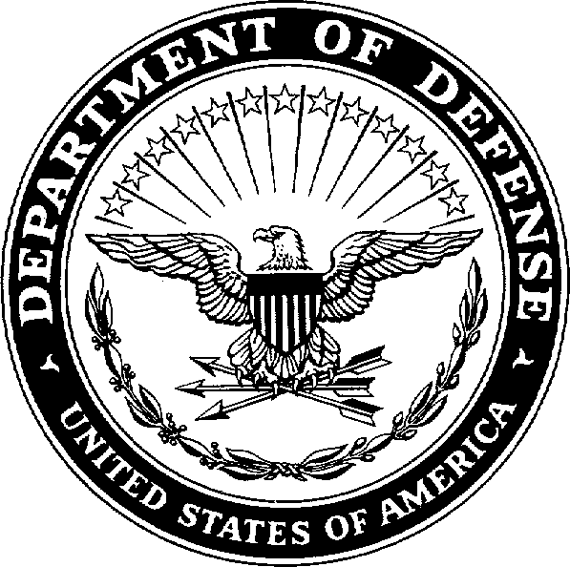
REPLY TO ATTENTION OF:

AMIM-GOW-WR
DEPARTMENT OF THE ARMY
US ARMY INSTALLATION MANAGEMENT COMMAND HEADQUARTERS, UNITED STATES ARMY GARRISON, FORT GORDON 307 CHAMBERLAIN AVENUE
FORT GORDON, GEORGIA 30905-5730

MEMORANDUM FOR INSTRUCTION/INTENT TO PLAY

SUBJECT: 2023 Unit Level Outdoor Soccer for Men/Women and Morning Programs

- GENERAL: The Fort Gordon 2023 Unit Level Outdoor Soccer Programs will be conducted during the period of February –April 2023.

- ORGANIZATION: The Unit Level Outdoor Soccer Program will be based upon unit level competition. Individual registration will be accepted from members of units that do not have an organized team. The Sports Office will make assignments. Units desiring to enter a team must submit their Memorandum of Intent not later than 26 January 2023 to the Sports Office (Bldg. 44401). The attached memorandum is provided for convenience in notifying the Sports Office.

RESPONSIBILITIES:

  - Sports Director: Responsible to Directorate of Family and Morale, Welfare and Recreation (DFMWR) for planning, organizing, scheduling, implementing and overall supervision of the league, resolution of problems, complaints and protest.

  - Unit Commanders:

    - Submit appropriate attached Memorandum(s) (i.e. Unit Level Soccer Program for Men/Women or Morning Soccer Program) of Intent to participate not later than 26 January 2023. Units may participate in one or both programs.

    - Notify the Sports Office in your Memorandum of Intent of known dates and daily times the unit will not be available for competition due to military training, exercises, change of command, etc.

    - Ensure the coach or a designated representative attends a coach’s organization meeting (Bldg. 44401) at 1300 hours, 26 January 2023. Prior to scheduling of practice times attendance of coach/or representative at the organization meeting is required.

PROCEDURES AND RULES:

  - Games will be played according to the 2023 Federation International Football Association (FIFA) Soccer Rules and the additional/amended rules, which will be distributed, at the coach’s meeting.

  - Forfeit time will be game time. All teams must be on the field ready to play at the scheduled time. Failure to do so will result in a forfeit. Teams forfeiting two games for failure to play at the scheduled time will be dropped from the league including tournament play.

  - Cancellations will be accepted and rescheduled only for military commitments that involve the entire unit and only when the Sports Office (791-1142) has been notified prior to 1400 hours the day of the scheduled game.

ELIGIBILITY:

  - Team composition will be active duty personnel (ONLY) assigned/attached to that company for duty with one exception; units having one hundred or
fewer service members and having a twenty-four/seven mission obligation are allowed to have DOD/DA civilians (employed by their unit) play on their Unit Level Intramural Sports Teams.

  - Individuals, who are assigned to one company and attached to another, may play with either the company of assignment or the company to which attached. Once a player has participated with either company, participation with the other company will not be permitted.

  - Participants who are reassigned to another company during the season may elect to continue playing with the previously assigned company provided a memorandum is submitted to the Sports Office prior to participation with his/her previous company. Both the losing and gaining company commanders reflecting agreement for continued participation with the losing company must sign the memorandum.

  - Players ejected from a game for unsportsmanlike-like conduct will be suspended for one game. A player ejected from the game for unsportsmanlike-like conduct a second time during the season will be suspended for the remainder of the playing season, to include tournament games. A player who is detected participating in any manner during suspended period by any member of the sports staff, an official or opposing player, will automatically be suspended from further participation for the remainder of the season and the offending team will forfeit all games in which the suspended player participated.

  - Protests will be accepted based upon rule misinterpretation or player eligibility and will be filed with the lead official. Additionally, the protest must be submitted in

writing to the Sports Office by 1600 hours the following duty-date, containing the following information:

    - The date times and places of the game.

    - Names of the officials.

    - The rule and section of the official rule.

    - The decision and/or condition surrounding the cause for protest.

    - All essential facts involved in the matter of the protest.

- UNIFORMS: All teams are required to wear the same color jerseys with numbers during the games. Teams may obtain their own jerseys or get them from Sports Supply, Bldg. 44401, telephone 791-7857. If a team(s) shows-up to play without like jerseys, that team(s) will lose by forfeit. Two forfeits and your team is subject to being removed from the Fort Gordon 2023 Unit Level Soccer Programs.

- TROPHIES: Team trophies will be presented to the first, second, and third place teams. Individual trophies will be presented to the first and second place teams in the post-season tournament play only.

- Point of contact is Mr. Neil Smith, e-mail neil.j.smith.naf@army.mil or 791-1142.

Digitally signed by COGGINS.LARRY.WAYNE.1229921
COGGINS.LARRY.W

AYNE.1229921491
491
Date: 2022.10.28 10:39:10 -04'00'

Encl LARRY W. COGGINS
Chief, Recreation Division

MEMORANDUM FROM 27 October 2022 MEMORANDUM FOR: SPORTS OFFICE (Bldg. 44401)

SUBJECT: 2021 UNIT LEVEL MEN/WOMEN SOCCER PROGRAM

- My Unit has received the Letter of Memorandum concerning the 2021 Unit Level Men/Women Soccer Program Guidelines and does ( ) does not ( ) intend to participate.

- This unit cannot participate due to known military commitments on the following dates:

- This unit can ( ) cannot ( ) compete in games scheduled at 1700 hours.

- The POC for my unit is and the contact phone is
.

- POC e-mail

COMMANDING DATE

MEMORANDUM FROM 27 October 2022 MEMORANDUM FOR: SPORTS OFFICE (Bldg. 44401)
SUBJECT: 2021 MORNING LEVEL SOCCER PROGRAM

- My Unit has received the Letter of Memorandum concerning the 2021 Morning Level Soccer Program Guidelines and does ( ) does not ( ) intend to participate.

- This unit cannot participate due to known military commitments on the following dates:

- The POC for my unit is and the contact phone is
.

- POC e-mail

COMMANDING DATE

